**소스코드**

import numpy as np

def sigmoid(x):

return 1/(1+np.exp(-x))

np.set_printoptions(precision=4)

A = np.array([[0.9,0.3,0.4],[0.2,0.8,0.2],[0.1,0.5,0.6]])

B = np.array([[0.3,0.7,0.5],[0.6,0.5,0.2],[0.8,0.1,0.9]])

input = np.array([[0.9],[0.1],[0.8]])

hiddenLayerInput = np.dot(A,input)

print("HIDDEN LAYER INPUT")

print(hiddenLayerInput)

hiddenLayerOutput = hiddenLayerInput.copy()

hiddenLayerOutput[0][0] = sigmoid(hiddenLayerOutput[0][0])

hiddenLayerOutput[1][0] = sigmoid(hiddenLayerOutput[1][0])

hiddenLayerOutput[2][0] = sigmoid(hiddenLayerOutput[2][0])

print("HIDDEN LAYER OUTPUT")

print(hiddenLayerOutput)

outputLayerInput = np.dot(B,hiddenLayerOutput)

print("OUTPUT LAYER INPUT")

print(outputLayerInput)

outputLayerOutput = outputLayerInput.copy()

outputLayerOutput[0][0] = sigmoid(outputLayerOutput[0][0])

outputLayerOutput[1][0] = sigmoid(outputLayerOutput[1][0])

outputLayerOutput[2][0] = sigmoid(outputLayerOutput[2][0])

print("OUTPUT LAYER OUTPUT = FINAL RESULT")

print(outputLayerOutput)

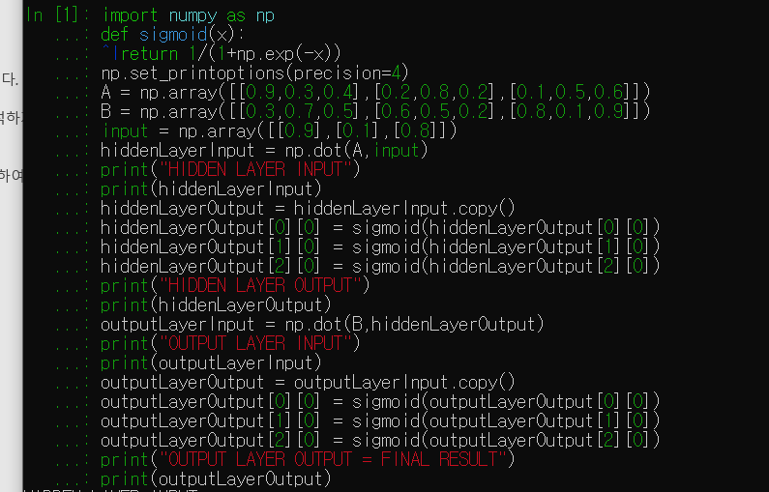

**결과**

